# AI BASED DISCOURSE FOR BANKING INDUSTRY

**A MINI PROJECT REPORT**

***Submitted by***

|  |  |
| --- | --- |
| **DHARSHINI P (111720102033)** |  |
| **HEMALA R (111720102043)** |  |
| **JANAVI S (111720102046)**  **ANSHIKA S (111720102009)** |  |

***in partial fulfillment for the award of the degree of***

# BACHELOR OF ENGINEERING

## IN

**COMPUTER SCIENCE AND ENGINEERING**

**R.M.K. ENGINEERING COLLEGE**

### (An Autonomous Institution)

#### R.S.M. Nagar, Kavaraipettai-601 206



**November 2023**

R.M.K. ENGINEERING COLLEGE

(An Autonomous Institution)

R.S.M. Nagar, Kavaraipettai-601 206

**BONAFIDE CERTIFICATE**

Certified that this project report **“AI based discourse for banking industry”** is the bonafide work of **Dharshini P (111720102033), Hemala R (111720102043), Janavi S(111720102046), Anshika S(111720102009)** who carried out the **20CS513 Mini Project and Design Thinking** work under my supervision**.**

|  |  |
| --- | --- |
| **SIGNATURE**  **Dr. T. Sethukarasi, M.E., M.S. Ph.D., Professor and Head**  Department of Computer Science and Engineering  R.M.K. Engineering College  R.S.M. Nagar, Kavaraipettai, Tiruvallur District– 601206. | **SIGNATURE**  **Ms.S.D.Lalitha**  **Supervisor**  Assistant professor  Department of Computer Science and Engineering  R.M.K. Engineering College  R.S.M. Nagar, Kavaraipettai,  Tiruvallur District–601206. |

Submitted for the Project Viva–Voce held on ……………………… at **R.M.K. Engineering College**, Kavaraipettai, Tiruvallur District– 601206.

#### INTERNALEXAMINER

**ACKNOWLEDGEMENT**

We earnestly portray our sincere gratitude and regard to our beloved **Chairman Shri. R. S. Munirathinam, our Vice Chairman, Shri. R. M. Kishore** and **our Director, Shri. R. Jyothi Naidu,** for the interest and affection shown towards us throughout the course.

We convey our sincere thanks to our **Principal**, **Dr. K. A. Mohamed Junaid,** for being the source of inspiration in this college.

We reveal our sincere thanks to our **Professor and Head of the Department, Computer Science and Engineering, Dr. T. Sethukarasi,** for her commendable support and encouragement for the completion of our project.

We would like to express our sincere gratitude for our Mini Project Coordinator **Ms. P. Baby Shamini, Assistant Professor**and project guide Ms.S.D.Lalitha,assistant professor for their valuable suggestions towards the successful completion for this project in a global manner.

We take this opportunity to extend our thanks to all faculty members of Department of Computer Science and Engineering, parents and friends for all that they meant to us during the crucial times of the completion of our project.

## TABLE OF CONTENTS

|  |  |  |
| --- | --- | --- |
| **CHAPTER** | **TITLE** | **PAGE NO** |
|  | **ABSTRACT** | 5 |
|  | **LIST OF FIGURES** | 6 |
| **1** | **INTRODUCTION** | 7 |
|  | 1.1 Problem Statement | 7 |
|  | 1.2 Project Scope and Objectives | 7 |
| **2** | **OVERALL DESCRIPTION** |  |
|  | 2.1 Project Specification | 8 |
|  | 2.2 Use Case Diagrams | 9 |
|  | 2.3 Design | 10 |
|  | 2.4 System Architecture | 11 |
| **3** | **EXTERNAL INTERFACE REQUIREMENTS** | |
|  | 3.1 User Interfaces | 12 |
|  | 3.2 Hardware Interfaces | 12 |
|  | 3.3 Software Interfaces | 13 |
| **4** | **TESTING** |  |
|  | 4.1 Test Plan | 14 |
|  | 4.2 Test Procedure | 14 |
|  |  |  |
| **5** | **FUTURE ENHANCEMENTS** | 15 |
| **6** | **CONCLUSION**  **REFERENCES**  **SAMPLE CODING**  **SCREENSHOTS** | 16 |
|  |  |  |

**ABSTRACT**

The advent of digital banking has introduced a new era of convenience, but it has also given rise to a significant surge in frauds and scams. These deceptive practices render the system susceptible to fraudulent transactions, eroding trust and reliability. To address these challenges, this project presents an innovative redesign of the current system, with the primary objective of making online banking not only reliable but significantly more efficient. AI has emerged as a pivotal force in shaping discourse and communication within the banking sector, involving interactions with customers, stakeholders, and within the organization itself. Central to this project is the implementation of scam detection algorithms, aimed at swiftly identifying and preventing fraudulent transactions. Of particular concern are credit card-related scams, which have been a common source of illicit financial activities. By enhancing the security of online transactions and promptly detecting these fraudulent practices, this project aims to rebuild trust among users and reinforce the integrity of the system. Moreover, this project goes a step further in assisting bankers by leveraging AI to analyze loan risks. It can predict a customer's creditworthiness and likelihood to repay loans, enabling banks to make more informed lending decisions. In doing so, this project extends its benefits to both clients and bankers, fostering a more secure and efficient financial ecosystem. As an integral component of the national economy, banks face the imperative to adopt advanced management systems to enhance their service capabilities and operational efficiency, vital for maintaining competitiveness and expanding profitability in today's fiercely competitive landscape.

## LIST OF FIGURES

|  |  |  |
| --- | --- | --- |
| **FIG.NO** | **FIGURE NAME** | **PAGE NUMBER** |
| 1. | Use case diagram | 9 |
| 2. | design | 10 |
| 3. | System architecture | 11 |

**CHAPTER 1 INTRODUCTION**

* 1. **Problem Statement**

The main problem with this statement is insecure online transactions in the banking industry. The risks associated with tampering with sensitive data stored on online banking websites pose a significant threat to clients, eroding their trust in the system. The current system diligently monitors transactions and user activity. If there is even a minor deviation from normal behavior, the system promptly flags it as a potentially fraudulent transaction and takes the necessary action to freeze the corresponding bank accounts.

## Project Scope and Objective:

#### Scope of the Project:

The project's scope involves real-time monitoring of online transactions and assessing their fraud risk levels. Additionally, a detailed analysis of client accounts is conducted to evaluate their loan risks.

## Objective of the Project:

The objective of our project, "Recognition," is to enhance the security of the e-banking system, improve fraud detection capabilities, and reduce the likelihood of tampering. Furthermore, the project aims to assist the bank in identifying creditworthy clients who have the ability to repay their loans.

# CHAPTER 2

**OVERALL DESCRIPTION**

**2.1 EXISTING SYSTEM**

E-banking services, including telephone banking, online banking, and mobile banking have revolutionized and greatly enhanced the convenience of people's daily lives. While the benefits are undeniable, the rise of e-banking has brought about new challenges, with security standing out as a prominent issue. Ensuring the protection of sensitive financial data and personal information has become increasingly crucial, given the growing sophistication of cyber threats and the potential for unauthorized access to accounts. Furthermore, another pressing issue in the e-banking landscape is the occasional failure of banking institutions to accurately identify their clients using existing data analytics algorithms. Thus, the ongoing development of robust security measures and improved client identification techniques is essential in the ever-evolving world of e-banking

**2.2 PROPOSED SYSTEM**

In our proposed system, transactions will undergo real-time monitoring, and their fraud risk levels will be assessed using Artificial Intelligence algorithms. If a transaction's risk level exceeds a predefined threshold, the associated account will be frozen. This will be accomplished using the Random Forest Classifier. Additionally, our project encompasses the process of analyzing vast amounts of client data to extract valuable insights for loan risk prediction. When addressing credit risk, we will explore a method that investigates the causes and effects of mortgage credit risk on credit defaults. This approach will involve the use of various algorithms such as logistic regression, decision trees, support vector machines, Naïve Bayesian, and k-nearest neighbors.

**2.3 USECASE DIAGRAM**

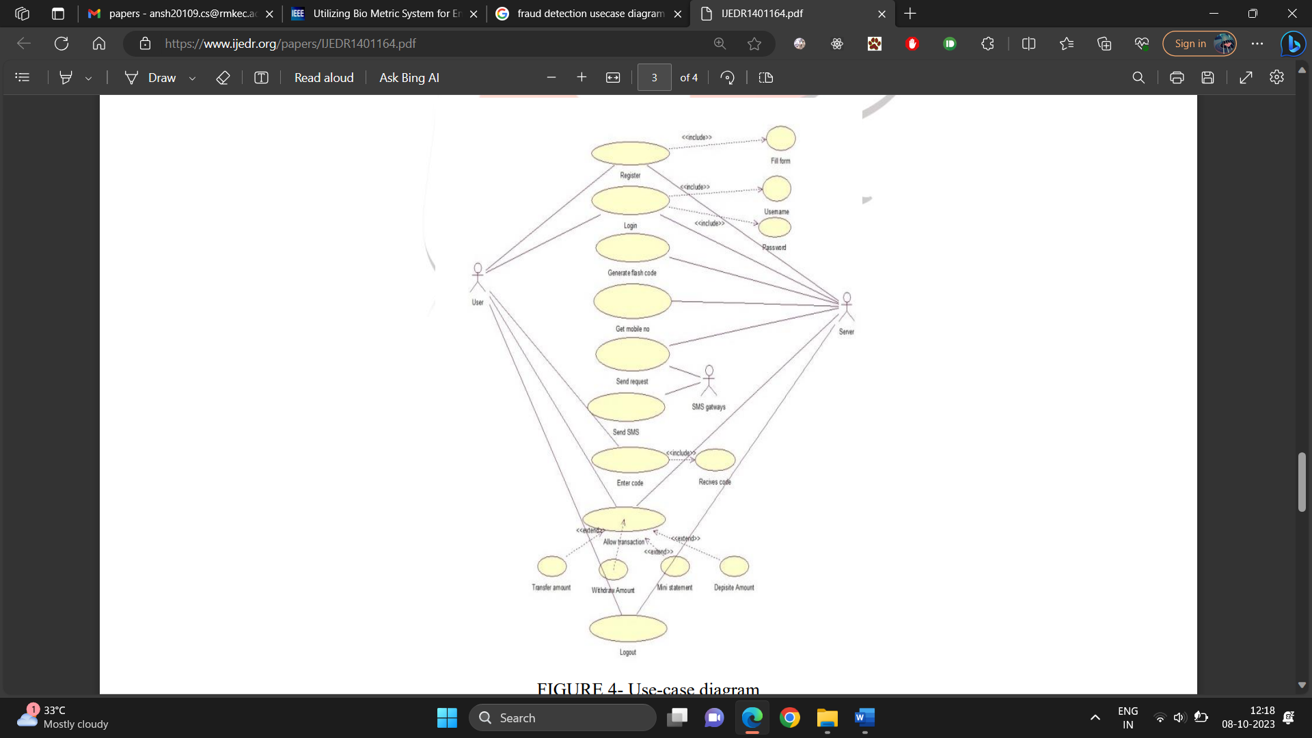

**2.4** **DESIGN**

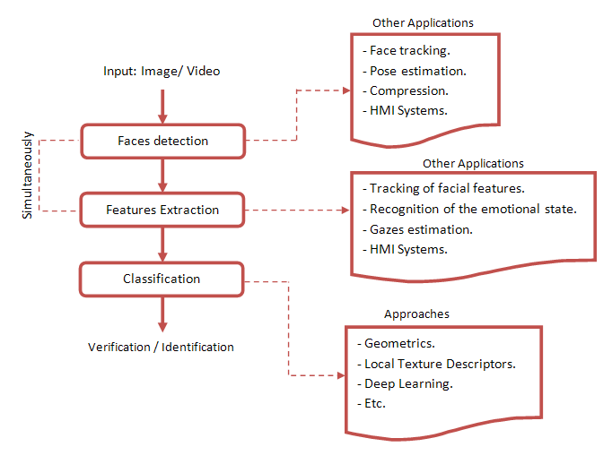

**2.6 SYSTEM ARCHITECTURE**

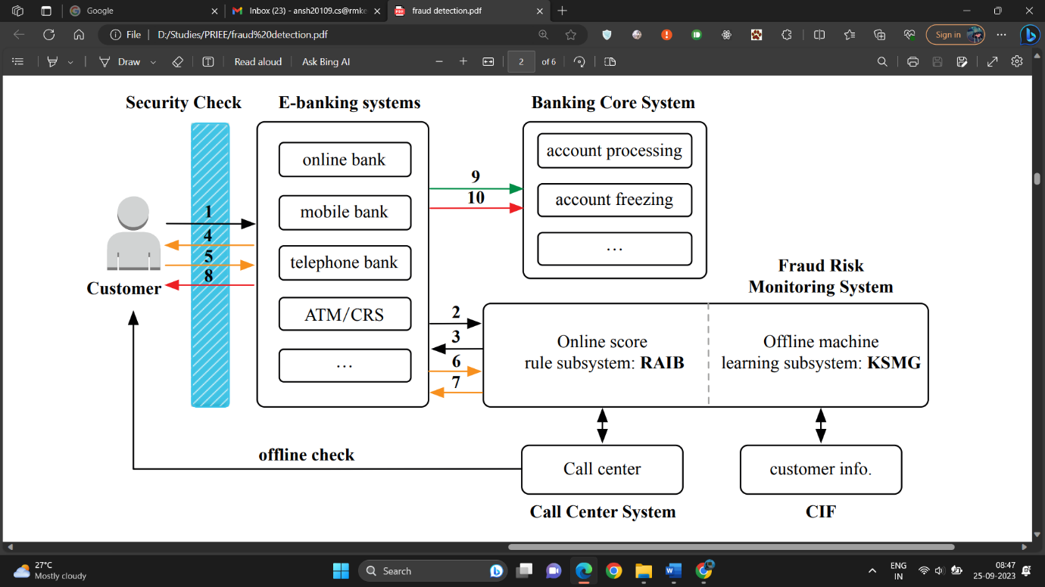

Fraud Transaction Detection

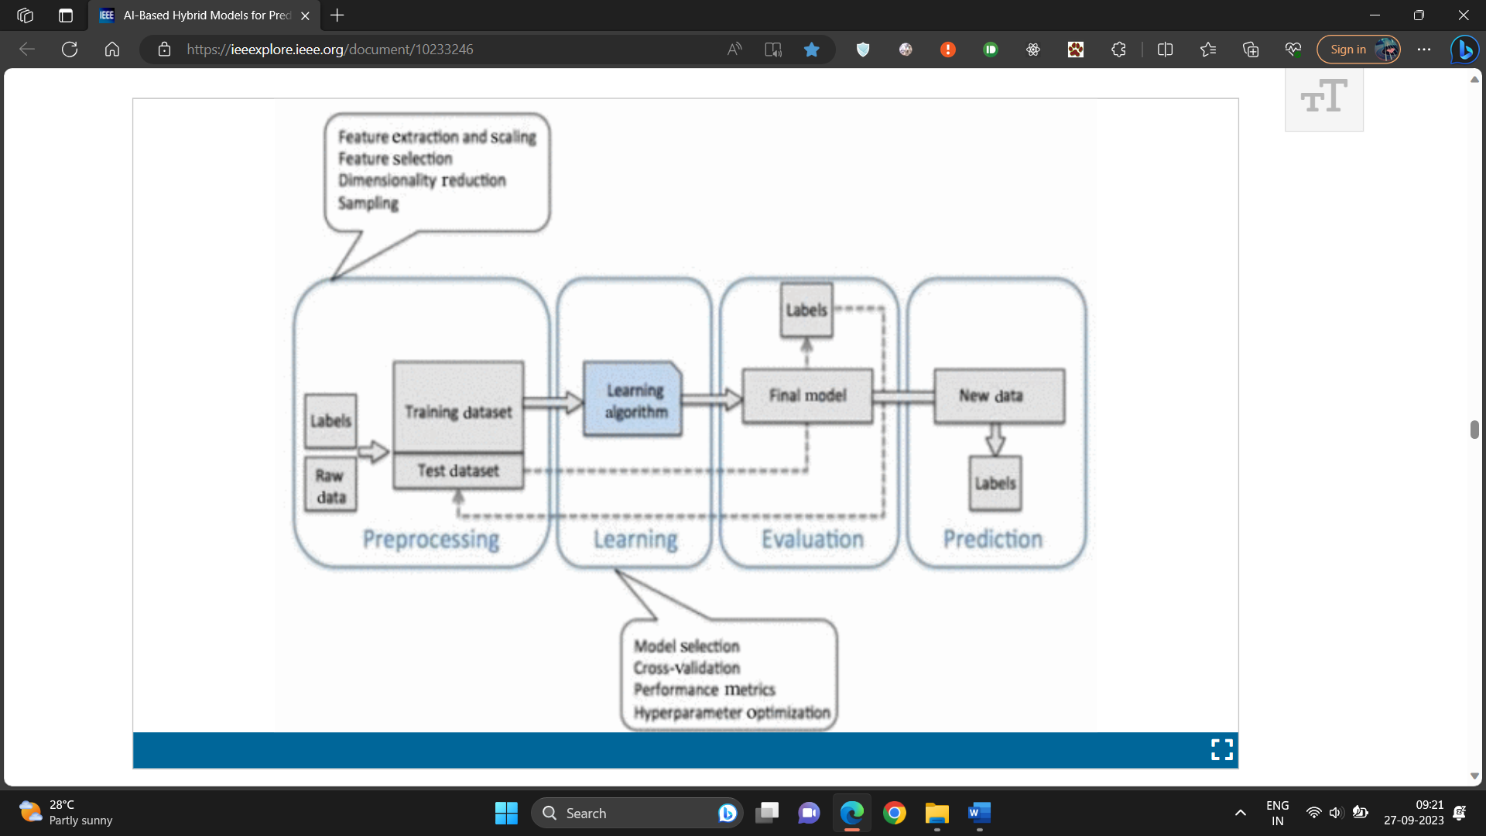

Loan Risk Prediciton

**CHAPTER 3**

**LITERATURE SURVEY**

|  |  |  |  |  |  |  |
| --- | --- | --- | --- | --- | --- | --- |
| S. NO | NAME OF THE JOURNAL | ALGORITHMS | PARAMETER 1 | PARAMETER 2 | PARAMETER 3 | PARAMETER 4 |
| 1 | Performance, Efficiency, and Target Setting for Bank Branches : Time Series With Automated Artificial Intelligence, Iiker Met, 2022 | Last Value Naïve, Seasonal Naïve, Average Value, Naïve Zeroes, Naïve GLS. | Sensitivity | Specificity | Recall | Precision |
| 2 | Utilizing Bio Metric System for Enhancing Cyber Security in Banking Sector : A Systematic Analysis , Habib Ullah Khan , 2023 | Internet of things, Artificial Intelligence, Cyber Security, Fintech | True positive rate | False positive rate | F1-score | Accuracy |
| 3 | GLEAN: Generative Latent Bank for Image Super-Resolution and Beyond, Kelvin C.K. Chan, 2022 | GLEAN (A Client-side algorithm) | Precision | Accuracy | True positive rate | False positive rate |
| 4 | Adaptation of a Real Time Deep Learning Approach With an Analog Fault Detection Technique for Reliability Forecasting of Capacitor Banks Used in Mobile Vehicles, Mohammad A. Rezaei, 2022 | Deep Learning (Fault Detection Technique) | Error rate | Split set | Performance | Classifiers |
| 5 | Taxonomy of Fraud Detection Metrics for Business Processes, Badr Omair, 2020 | Process-Based-Fraud (PBF) | Frequency | Performance | Value | Simulation Setup |
| 6 | FraudAuditor : A Visual Analytic Approach For Collusive Fraud In Health Insurance, Jiehui Zhou, 2023 | Improved Community Detection Algorithm, Suspicious Group Mining. | Mean Group | Current Group | Outliers | Suspicious Group |
| 7 | CoDetect : Financial Fraud Detection With Anomaly Feature Detection, Dongxu Huang, 2018 | Logistic Regression, Supervised Learning, optimization algorithms | Outlier point | Merge Scenario | Ring Scenario | Synthetic Data, Money Laundering Data. |
| 8 | A Systematic Literature Review of Fraud Detection Metrics in Business Processes, Ahmad Alturki, 2020 | Process Based Fraud (PBF) algorithm | Frequency | Performance | Value | Simulation Setup |
| 9 | Credit Card Fraud Detection Using State-of-the-Art Machine Learning and Deep Learning Algorithms, Iqra Malik, 2022 | Decision Tree, Random Forest, Support Vector Machine. | Convo layer(convo+ReLu) | Pooling layer | Fully connected layer(FC) | SoftMax/logistic layer |
| 10 | Delinquent Events Prediction in Temporal Networked Guarantee Loans, Dawei Cheng, 2020 | Temporal Delinquent Event Prediction framework(TDEP) | Precision | Number of Neighbors | Layouts of Community Detection by Random Walk | Network Clustering Results By Our Proposed TDEP |
| 11 | Al- Based Hybrid Models For Predicting Loan Risk in The Banking Sector, Vikas Kumar, 2023 | Gradient Boost, Decision Tree, Logistic Regression. | Count Vectorizer | Term Frequency- Inverse Document Frequency (TF-IDF) | Support Vector Machines | Naïve Bayes Classifier. |
| 12 | A Big Data Mining Approach of PSO-Based BP Neural Network for Financial Risk Management With IoT, Hangjun Zhou, 2019 | Particle Swarm Optimization (PSO) Based Backpropagation (BP) Neural Network | True Positive Rate | False Positive Rate | F1-Score | Accuracy |
| 13 | Network Based Computational Techniques to Determine the Risk Drivers of Bank Failures During a Systematic Banking Crisis, Andreas Krause, 2018 | Optimization Algorithms | Number Of Banks | Assests | Power Law Exponent | Recovery Rate |
| 14 | Predicting Default Risk on Peer-to-Peer Lending Imbalanced Datasets, Yen-Ru Chen, 2021 | Peer-to-Peer Lending Algorithm(P2P Lending) | Loan Amount | Loan Purpose | Annual Income | Employment Length |
| 15 | An Investigation of Credit Card Default Prediction In The Imbalanced Datasets, Talha Mahboob Alam, 2020. | Hypothesis-Testing-Technique | Random Undersampling | Cluster Centroid | Random Oversampling | Adaptive Synthetic |

# CHAPTER 4 TESTING

## TESTPLAN

## 

4.1.1 Objective Verify that the camera can capture a live video feed and is able to convert image into grayscale.

 4.1.2 Setup

We ran the main VI (Working Detection.vi) and checked whether the image of camera feed is being displayed in front panel or not.

4.1.3 Results

We were successfully able to capture live feed of video .Also, the image captured is in grayscale which passed our second test as well.

## 4.2 TESTPROCEDURE

4.2.1 Objective

Verify that the image is captured from camera is processed and compared with saved templates for face recognition.

4.2.2 Setup

 We ran the main VI (Working Detection.vi) in debugging mode to see whether the face was detected as well as to check number of matches ==1 for the student matched.

4.2.3 Results

We were successfully able to detect face as seen in value changes in debugging mode. The face corresponding to image in database caused number of matches to change to 1 which triggered the case structure to case = 1 and therefore passed the value further to Write to Spreadsheet module.

## 4.3 TEST DELIVERABLES

4.3.1 Objective

Verify that the spreadsheet is updated to corresponding present as soon as image is detected. The “Present” should be marked against the person detected only.

4.3.2 Setup

 We ran the main VI (Working Detection.vi) and checked Attendance Sheet Section to change from “Absent” to “Present” on detection of person.

4.3.3 Results

 We were successfully able to detect face and change the value of corresponding face from “Absent” Before to “Present”.

# CHAPTER 5

## FUTURE ENHANCEMENTS

The future of fraud detection in the banking industry using AI is promising and likely to see several enhancements. Continued advancements in machine learning algorithms, including deep learning and reinforcement learning, will enable banks to develop more accurate and sophisticated fraud detection models. These models can adapt to evolving fraud patterns and offer real-time detection and response. To add an extra level of security, behavioral biometrics such as keystroke dynamics, voice recognition and fingerprint scanning, to verify the identity of customers during transactions. Further, NLP algorithms can be used to analyze customer interactions, such as chat conversations, emails, and call center transcripts, to identify signs of fraudulent activity. AI-driven graph analytics can help detect complex fraud networks and money laundering schemes by analyzing the connections and relationships among entities, accounts, and transactions. Further techniques can also be explored to aid financial institutions make more accurate and responsible lending decisions. Future enhancements will focus on creating AI models that provide clear explanations for loan approval or rejection, which is vital for regulatory compliance and customer trust. Future enhancements will focus on creating AI models that provide clear explanations for loan approval or rejection, which is vital for regulatory compliance and customer trust. Implementing models that can adapt and learn over time as new data becomes available will help ensure the accuracy and relevancy of loan predictions. The future of loan prediction using data analytics will require a holistic approach that encompasses advanced technology, data sources, ethical considerations, and ongoing adaptation to changing market conditions and regulations. These enhancements will empower financial institutions to make more informed lending decisions while also improving customer satisfaction and minimizing risks.

**CHAPTER 6**

**CONCLUSION**

Fraud risk monitoring stands as a critical focal point in the realm of e-banking services. It is imperative for banks to establish a robust fraud risk monitoring system for electronic banking transactions It is necessary for banks to construct a fraud risk monitoring system for banks to construct a fraud risk monitoring system for e-banking transactions. The incorporation of artificial intelligence algorithms has showed its indispensable role in the world of business by enhancing operations, such as sales forecasting and minimizing the potential for human errors in prediction and analysis. Leveraging this potential, we have harnessed artificial intelligence in conjunction with historical data, including client data such as annual income and loan history, to construct a predictive model. This model foretells how clients are likely to respond to a term deposit offering by a bank. Implementing machine learning algorithms, we achieved several significant advantages. Firstly, it enables the bank to create more precise customer segmentation. Furthermore, it substantially reduces the margin for human error, a factor that can be costly and detrimental in financial operations. This streamlined approach not only enhances cost efficiency but also significantly improves time efficiency, allowing the bank to make decisions swiftly and with confidence. Ultimately, the adoption of this advanced technology augments the overall customer experience, demonstrating the bank's commitment to delivering personalized and responsive services.

## REFERENCES

[1] [Habib Ullah Khan](https://ieeexplore.ieee.org/author/37088335010), [Habib Ullah Khan](https://ieeexplore.ieee.org/author/37088335010), [Shah Nazir](https://ieeexplore.ieee.org/author/38246341900), [Faheem Khan](https://ieeexplore.ieee.org/author/37089231333),

Utilizing bio metric system for enhancing cyber security in banking sector: A Symmatic Analysis (25 July 2023)

[2] [Jiehui Zhou](https://ieeexplore.ieee.org/author/37089642674), [Jiehui Zhou](https://ieeexplore.ieee.org/author/37089642674), [Huanliang Wang](https://ieeexplore.ieee.org/author/37089642524), [Hui Ye](https://ieeexplore.ieee.org/author/37088230486),

FraudAuditor: A visual analytics approach for collusive fraud in health insurance (27 March 2023)

[3] [Badr Omair](https://ieeexplore.ieee.org/author/37087889662), [Ahmad Alturki](https://ieeexplore.ieee.org/author/37087889577),

Taxonomy of fraud detection metrics for business processes (13 April 2020)

[4] [Dongxu Huang](https://ieeexplore.ieee.org/author/37085358121), [Dejun Mu](https://ieeexplore.ieee.org/author/37273198900), [Libin Yang](https://ieeexplore.ieee.org/author/37675785700),

CoDetect: Financial Fraud Detection with Anomaly Feature Detection (26 March 2018)

[5] [Fawaz Khaled Alarfaj](https://ieeexplore.ieee.org/author/37085803874), [Iqra Malik](https://ieeexplore.ieee.org/author/37089365197), Naif Almusallam, Muhammad Ramzan,

Credit Card Fraud Detection using State-of-the-Art Machine Learning and Deep Learning Algorithms (12 April 2022 )

[6] [Dawei Cheng](https://ieeexplore.ieee.org/author/37086385381), [Zhibin Niu](https://ieeexplore.ieee.org/author/37086385937), [Liqing Zhang](https://ieeexplore.ieee.org/author/37280172400),

Delinquent Events Prediction in Temporal Networked-Guarantee Loans (13 October 2020)

[7] Vikas Kumar; Shaiku Shahida Saheb; Preeti; Atif Ghayas; Sunil Kumari,

‘AI-Based Hybrid Models for Predicting Loan Risk in the Banking Sector (29 August 2023)

[8] [Hangjun Zhou](https://ieeexplore.ieee.org/author/37405366800); [Guang Sun](https://ieeexplore.ieee.org/author/37087006478); [Sha Fu](https://ieeexplore.ieee.org/author/37895033900); [Jing Liu](https://ieeexplore.ieee.org/author/37089075975),

A Big Data Mining Approach of PSO-Based BP Neural Network for Financial Risk Management With IOT (22 October 2019)

[9] [Andreas Krause](https://ieeexplore.ieee.org/author/37086201428); [Simone Giansante](https://ieeexplore.ieee.org/author/37086379412),

Network-Based Computational Techniques to Determine the Risk Drivers of Bank Failures During a Systemic Banking Crisis (23 May 2018)

[10] [Talha Mahboob Alam](https://ieeexplore.ieee.org/author/37087225552); [Kamran Shaukat](https://ieeexplore.ieee.org/author/37085788454); [Ibrahim A. Hameed](https://ieeexplore.ieee.org/author/37085791748); [Suhuai Luo](https://ieeexplore.ieee.org/author/37402012900),

An Investigation of Credit Card Default Prediction in the Imbalanced Datasets (26 October 2020)

[11] [Wei Li](https://ieeexplore.ieee.org/author/37086482863); [Shuai Ding](https://ieeexplore.ieee.org/author/37086175456); [Yi Chen](https://ieeexplore.ieee.org/author/37089071511); [Shanlin Yang](https://ieeexplore.ieee.org/author/37292119500),

Heterogeneous Ensemble for Default Prediction of Peer to Peer Lending in China (01 March 2018)

[12] [Fairoz Nower Khan](https://ieeexplore.ieee.org/author/37089853726); [Amit Hasan Khan](https://ieeexplore.ieee.org/author/37087054122); [Lamiah Israt](https://ieeexplore.ieee.org/author/37087050192)

Credit Card Fraud Presiction and Classification using Deep Neural Network and Ensemble Learning (07 June 2020)

[13] [Zhu Xueping](https://ieeexplore.ieee.org/author/37088546474); [Li Qingnian](https://ieeexplore.ieee.org/author/37089570562); [Huang Ying](https://ieeexplore.ieee.org/author/37089569681); [Huang Lei](https://ieeexplore.ieee.org/author/37089569251); [Deng Pengying](https://ieeexplore.ieee.org/author/37089565561)

Fraud Prediction of Credit Card Customers Based on Xgboost Model and Multi-Layer Preception Model (18 October 2022)

[14] [M R Dileep](https://ieeexplore.ieee.org/author/37087441376); [A V Navaneeth](https://ieeexplore.ieee.org/author/37088590592); [M Abhishek](https://ieeexplore.ieee.org/author/37088820187)

A Novel Approach for Credit Card Fraud Detection using Decision Tree and Random Forest Algorithms (31 March 2021)

[15] [Pathipati Yasasvi](https://ieeexplore.ieee.org/author/37089816792); [S. Magesh Kumar](https://ieeexplore.ieee.org/author/37089610354)

Improve Accuracy in Prediction of Credit Card Approval using a Novel Xgboost compared with Decision Tree Algorithm (17 December 2022)

# SAMPLE CODING

|  |
| --- |
| <!DOCTYPE html> |
|  | <html lang="en"> |
|  |  |
|  | <head> |
|  | <!-- Required meta tags --> |
|  | <meta charset="utf-8"> |
|  | <meta name="viewport" content="width=device-width, initial-scale=1, shrink-to-fit=no"> |
|  |  |
|  | <!-- Bootstrap CSS --> |
|  | <link rel="stylesheet" href="https://stackpath.bootstrapcdn.com/bootstrap/4.3.1/css/bootstrap.min.css" integrity="sha384-ggOyR0iXCbMQv3Xipma34MD+dH/1fQ784/j6cY/iJTQUOhcWr7x9JvoRxT2MZw1T" crossorigin="anonymous"> |
|  |  |
|  | <!-- Style CSS --> |
|  | <link rel="stylesheet" href="style.css"> |
|  |  |
|  | <title>Face Verification</title> |
|  | </head> |
|  |  |
|  | <body> |
|  | <!-- Page Content --> |
|  | <div class="container"> |
|  | <div class="row"> |
|  | <div class="col-lg-12 text-center"> |
|  | <h1 class="mt-5">Face Verification</h1> |
|  | <p class="lead">Quick and simple face verification using HTML5 and JavaScript</p> |
|  | </div> |
|  | </div> |
|  | <div class="row justify-content-md-center"> |
|  | <div class="col-lg-4 text-center"> |
|  | <p><strong>Verification Photo</strong></p> |
|  | <!-- Canvas For Uploaded Image --> |
|  | <canvas id="uploadCanvas" width="300" height="300"></canvas> |
|  | <!-- Default Canvas Image --> |
|  | <img src="defaultupload.png" id="uploadedPhoto" alt="Default Upload Photo" /> |
|  | <!-- Upload Image Input & Upload Photo Button --> |
|  | <input type="file" name="image-upload" accept="image/png, image/jpeg"> |
|  | <button id="upload" type="button" class="btn btn-outline-primary btn-lg">Upload Photo</button> |
|  | </div> |
|  | <div class="col-lg-4 text-center"> |
|  | <p><strong>Video</strong></p> |
|  | <!-- Camera --> |
|  | <div class="camera-container"> |
|  | <video id="video" width="100%" height="300" autoplay="true"></video> |
|  | </div> |
|  | <!-- Take Photo Button --> |
|  | <button id="capture" type="button" class="btn btn-outline-primary btn-lg">Take Photo</button> |
|  | </div> |
|  | <div class="col-lg-4 text-center"> |
|  | <p><strong>Photo Taken</strong></p> |
|  | <!-- Canvas For Capture Taken --> |
|  | <canvas id="captureCanvas" width="300" height="300"></canvas> |
|  | <!-- Default Canvas Image --> |
|  | <img src="defaultphoto.png" id="capturedPhoto" alt="Default" /> |
|  | <!-- Verify Photos Button --> |
|  | <button id="verify" type="button" class="btn btn-outline-success btn-lg">Verify Photo</button> |
|  | </div> |
|  | </div> |
|  | <div class="row"> |
|  | <div class="col-lg-12 text-center"> |
|  | <!-- API Match Result & API Percentage Score --> |
|  | <h2 id="match" class="mt-5"></h2> |
|  | <p id="score" class="lead"></p> |
|  | </div> |
|  | <div class="col-lg-12 text-center"> |
|  | <!-- Error & Warning Alerts --> |
|  | <div class="alert alert-danger" id="errorAlert"></div> |
|  | <div class="alert alert-warning" id="warningAlert"></div> |
|  | </div> |
|  | </div> |
|  |  |
|  | <!-- Verify JS --> |
|  | <script src="verify.js"></script> |
|  |  |
|  | <!-- jQuery first, then Popper.js, then Bootstrap JS --> |
|  | <script src="https://code.jquery.com/jquery-3.3.1.slim.min.js" integrity="sha384-q8i/X+965DzO0rT7abK41JStQIAqVgRVzpbzo5smXKp4YfRvH+8abtTE1Pi6jizo" crossorigin="anonymous"></script> |
|  | <script src="https://cdnjs.cloudflare.com/ajax/libs/popper.js/1.14.7/umd/popper.min.js" integrity="sha384-UO2eT0CpHqdSJQ6hJty5KVphtPhzWj9WO1clHTMGa3JDZwrnQq4sF86dIHNDz0W1" crossorigin="anonymous"></script> |
|  | <script src="https://stackpath.bootstrapcdn.com/bootstrap/4.3.1/js/bootstrap.min.js" integrity="sha384-JjSmVgyd0p3pXB1rRibZUAYoIIy6OrQ6VrjIEaFf/nJGzIxFDsf4x0xIM+B07jRM" crossorigin="anonymous"></script> |
|  | </body> |
|  |  |
|  | </html> |

# 

# SCREENSHOTS

# 

# 